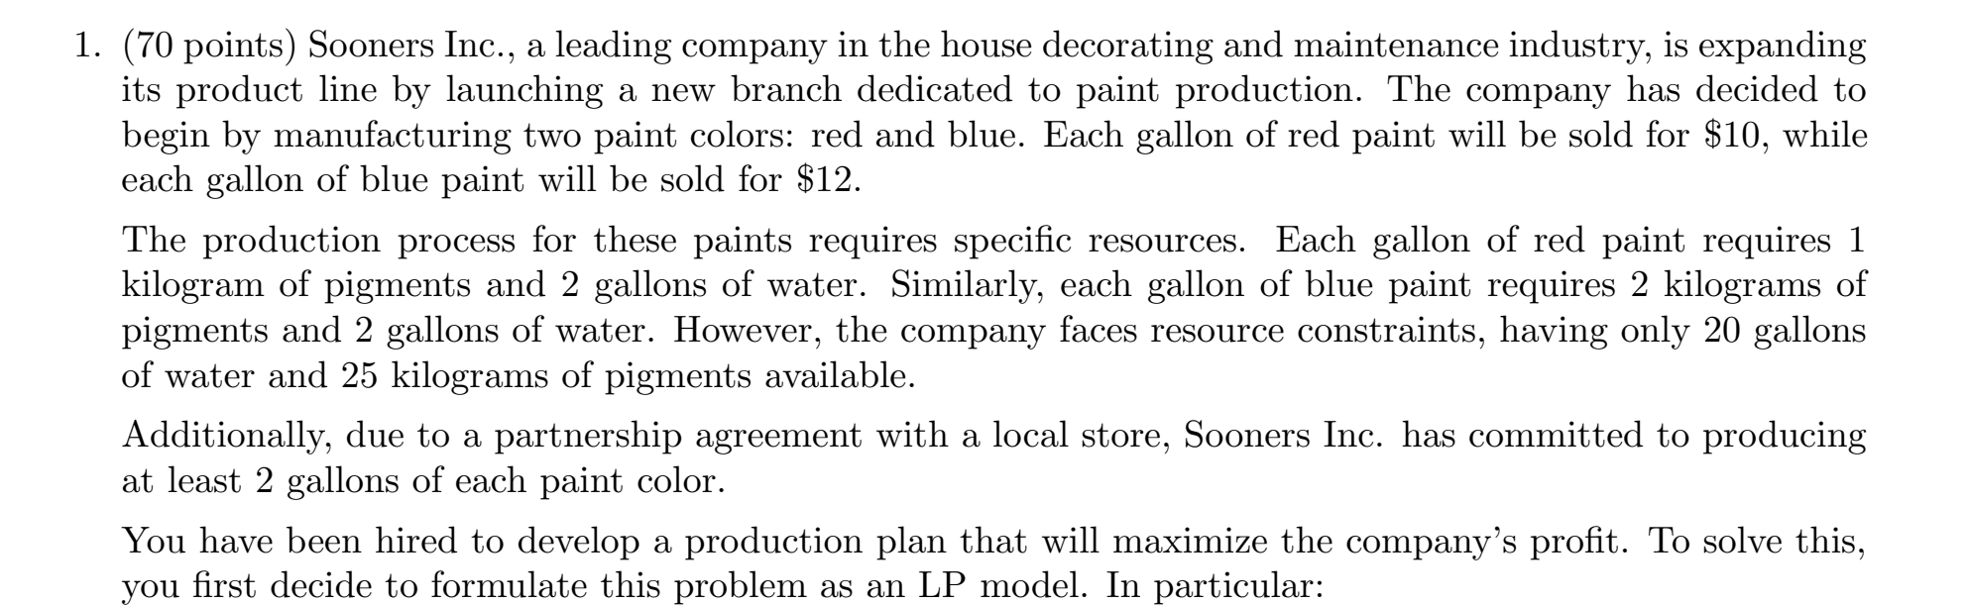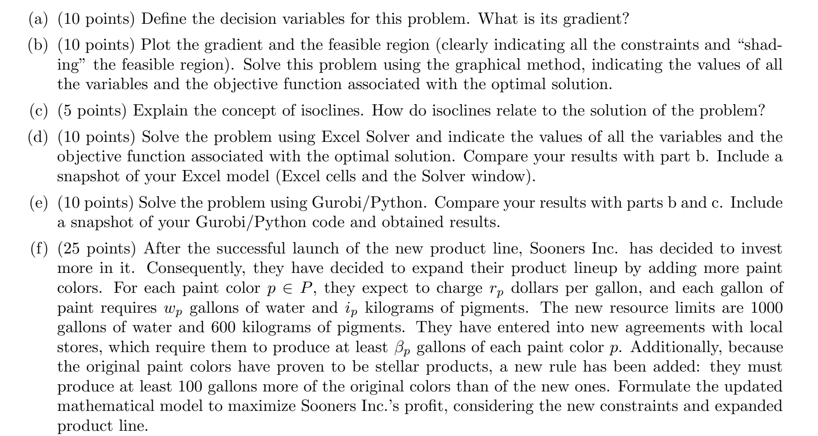Juan Mejia Homework 2

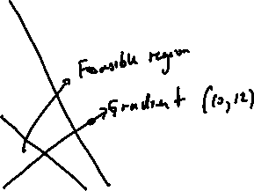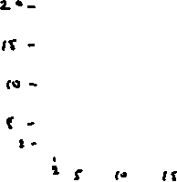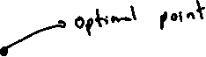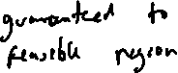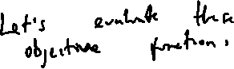

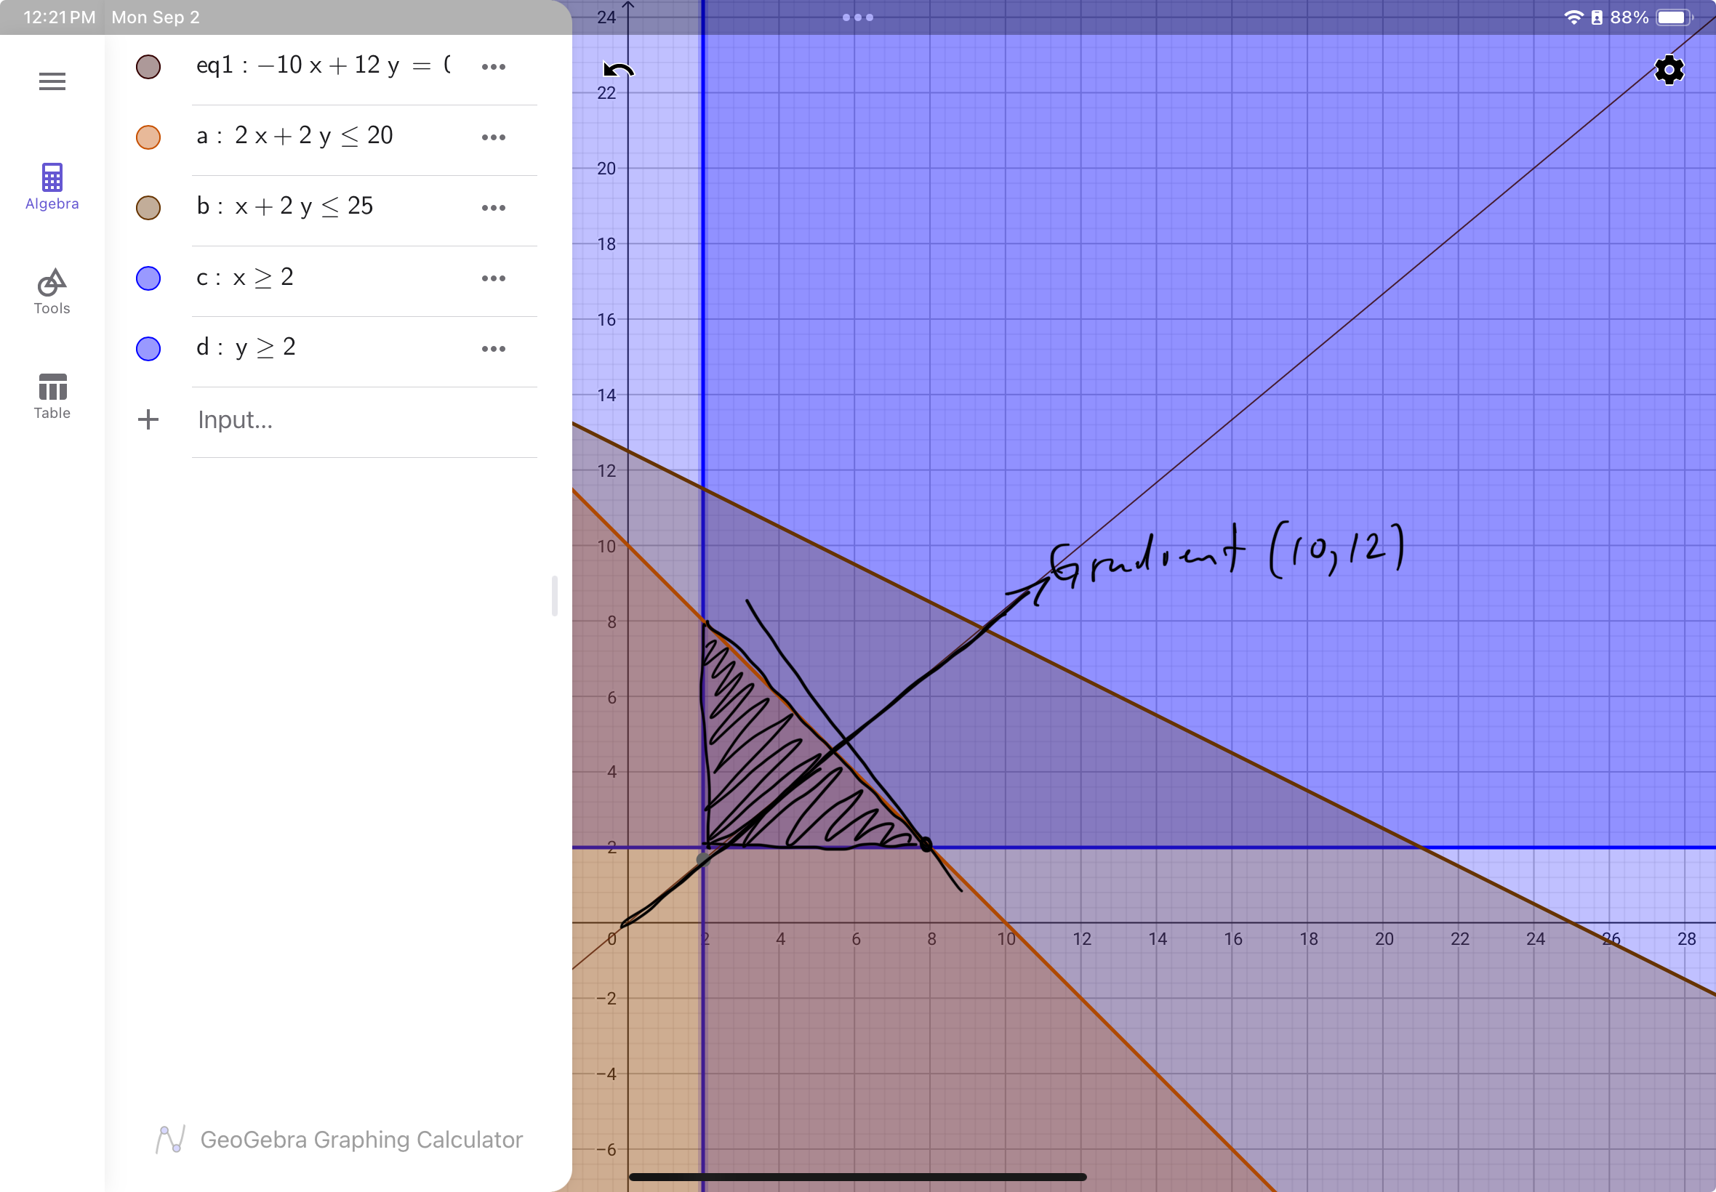

Figure 1. Model 1 graphical solution using geogebra.



Figure 2. Model and solution for problem 1 using Excel solver

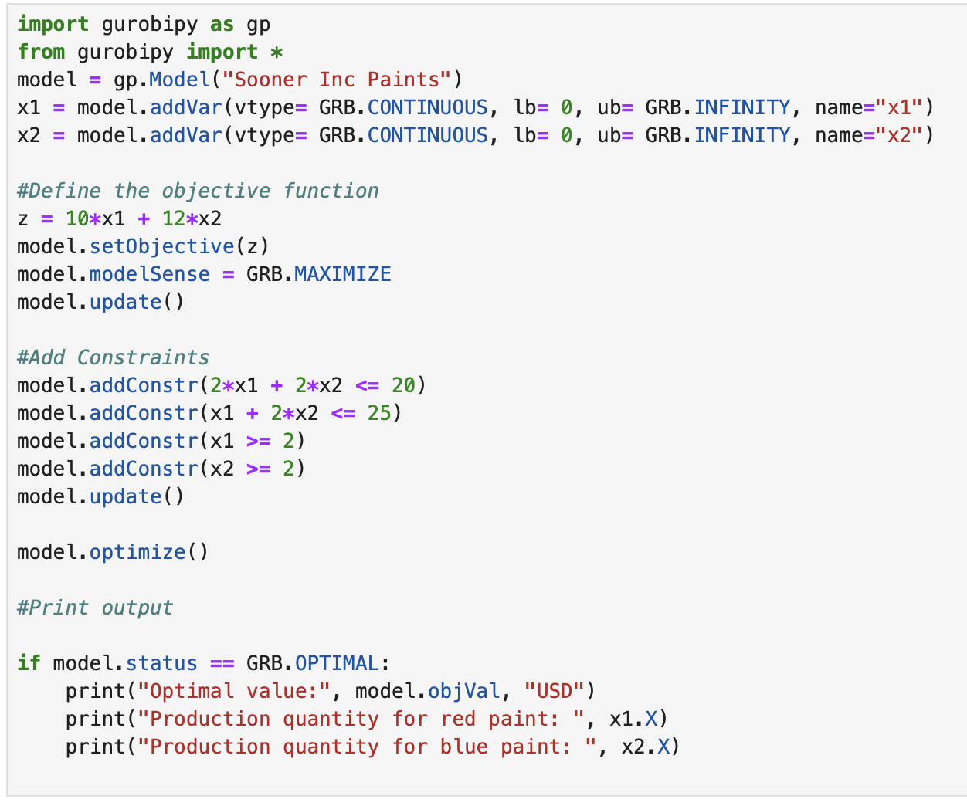



Figure 3. Model 1 in gurobi

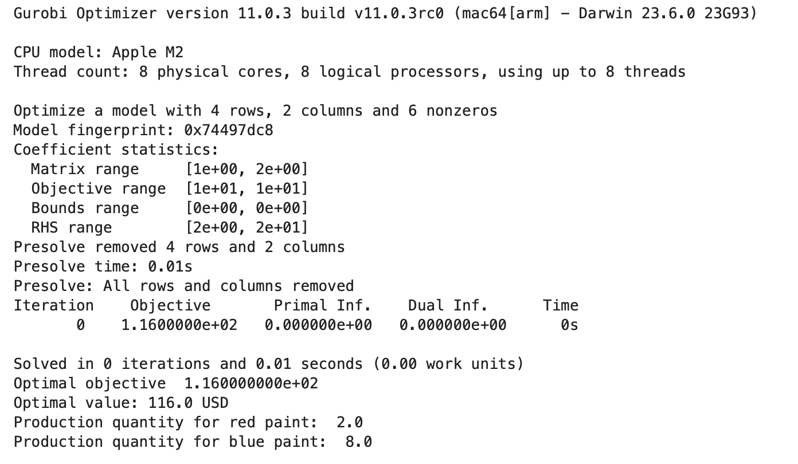

Figure 4. Solution for model 1 in gurobi



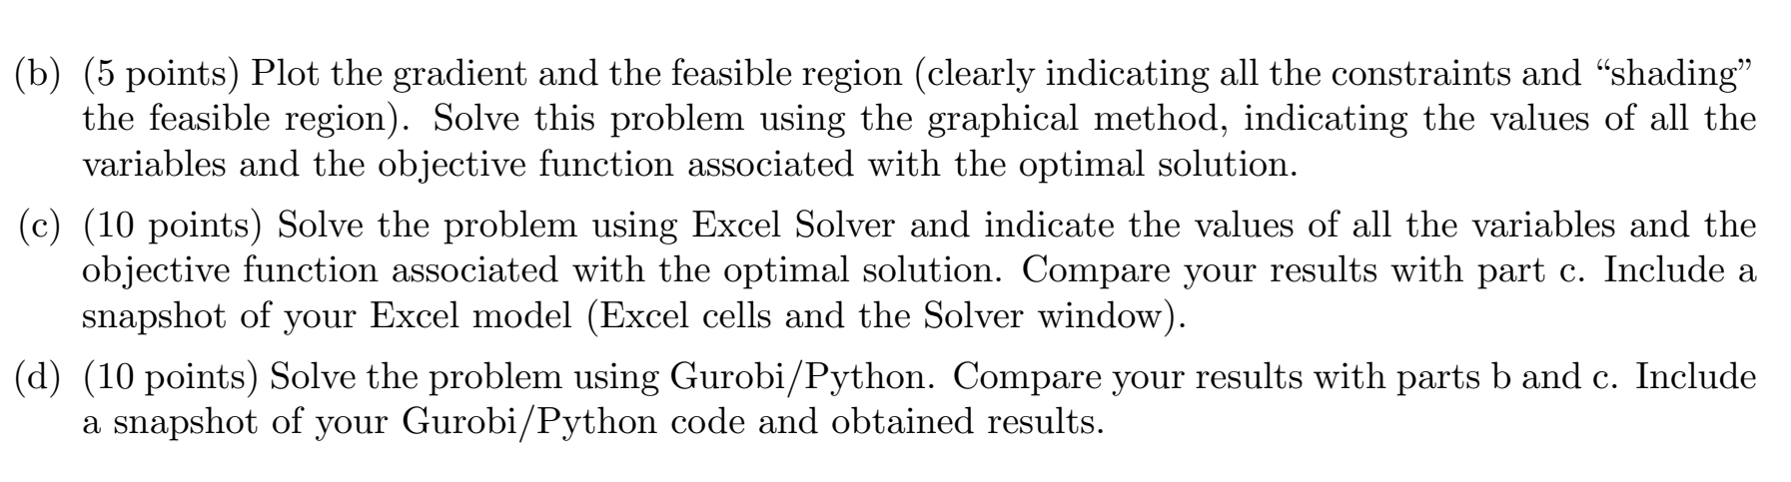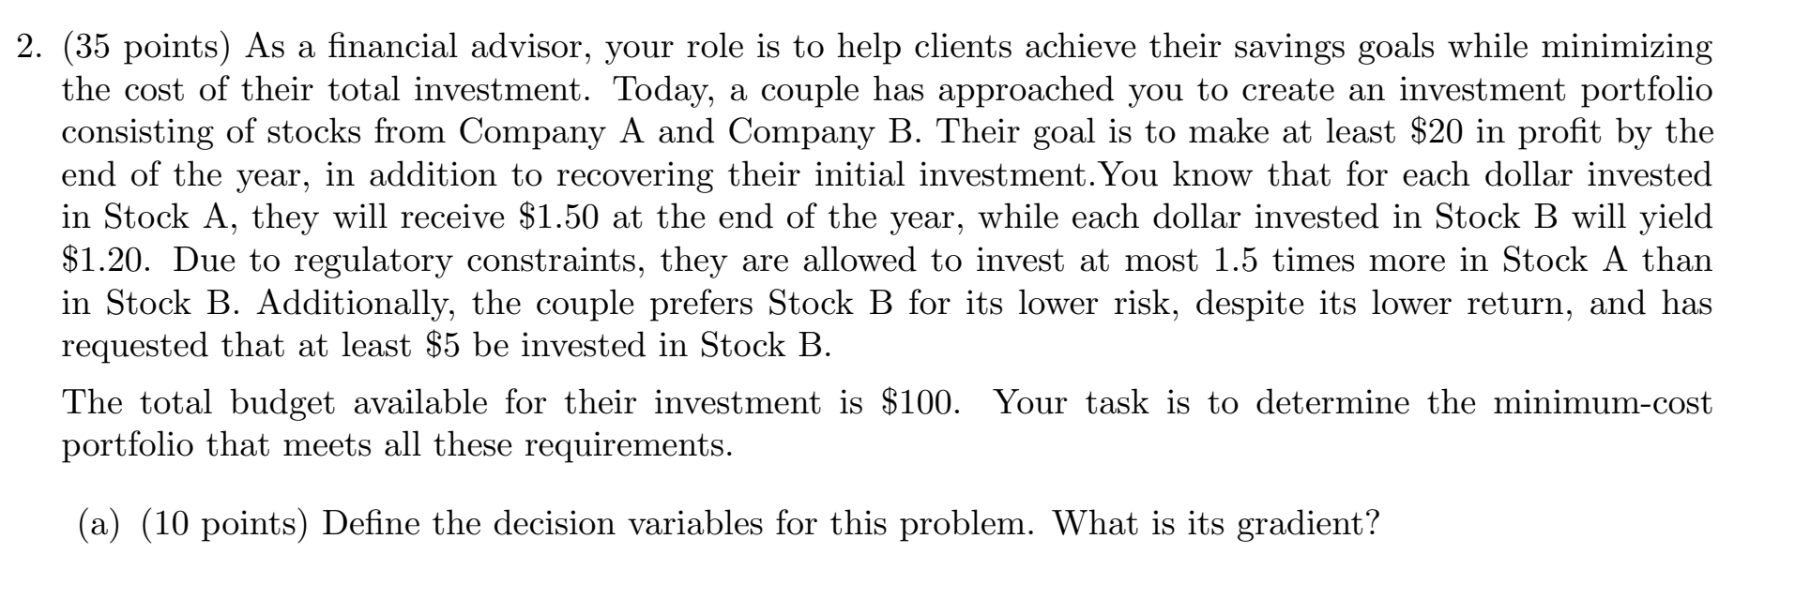

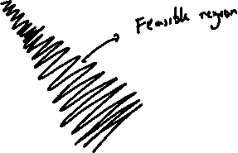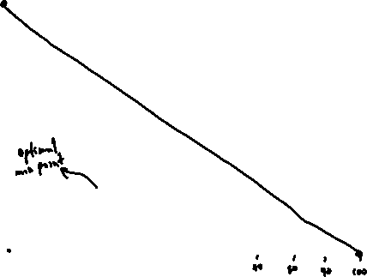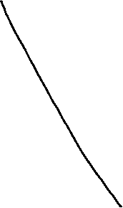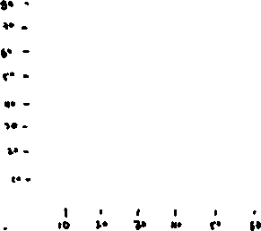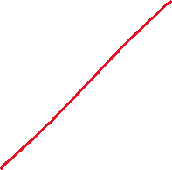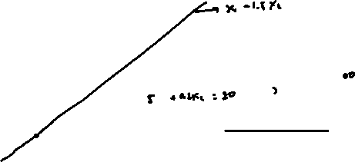

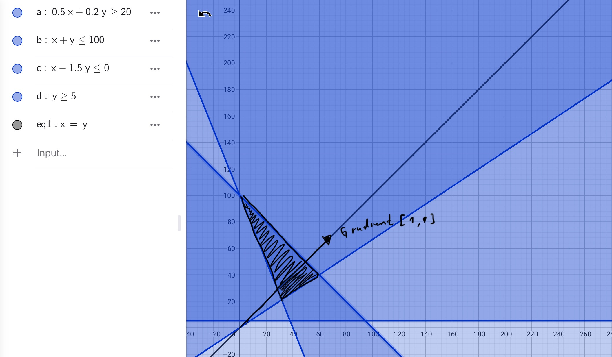

Figure 5. Model 2 graphical solution using geogebra.



Figure 6. Model and solution for problem 2 using Excel solver



Figure 7. Model 2 in gurobi

Figure 8. Solution for model 1 in gurobi